* 1. font-size: 18pt

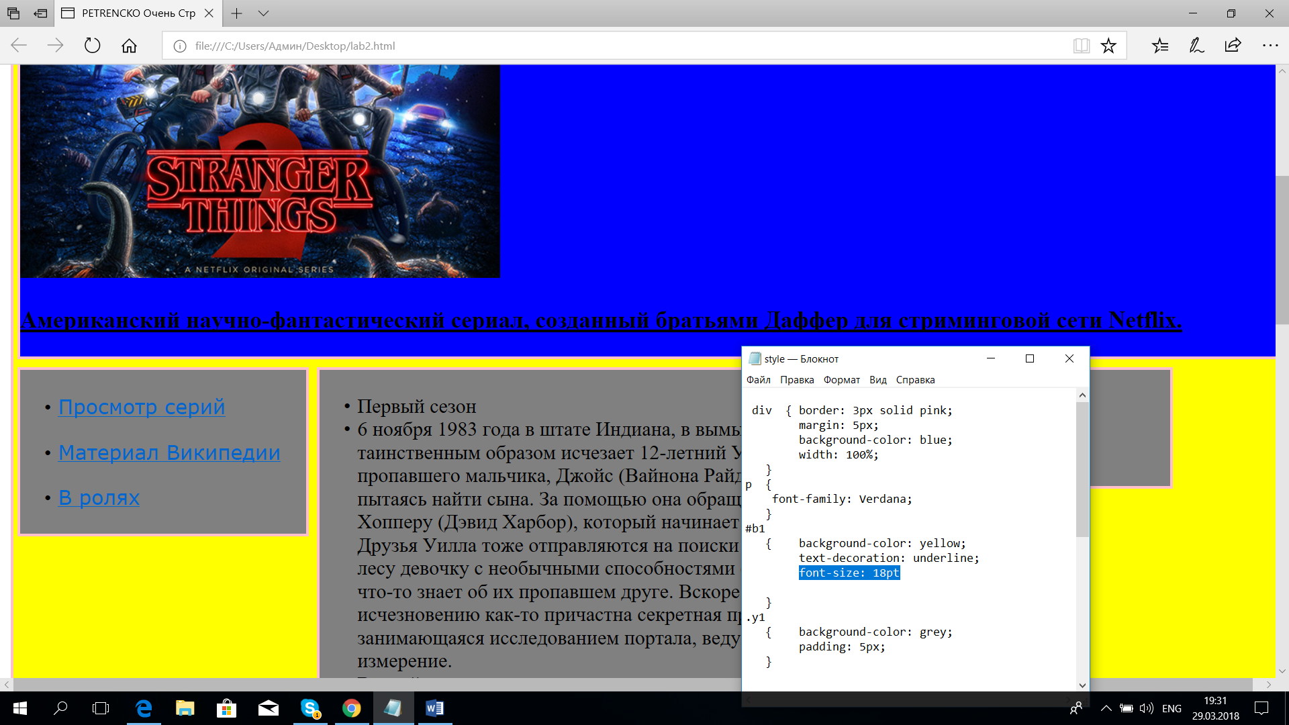

1.2color: red;

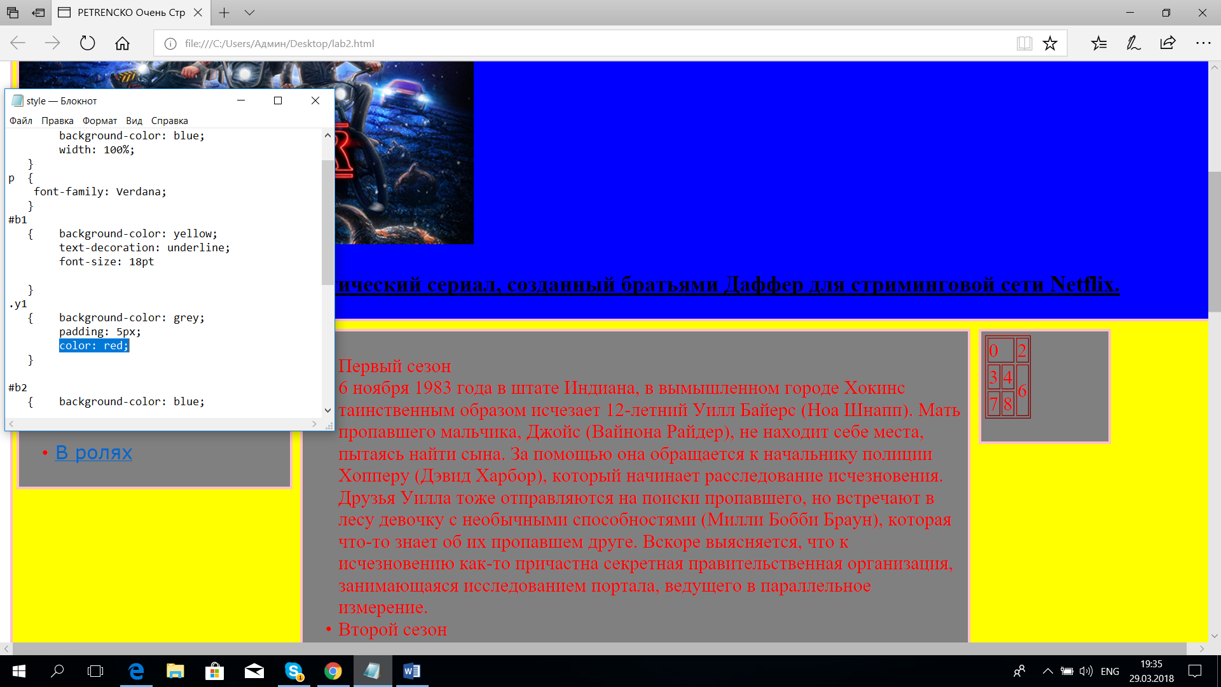

2.1 p {

font-family: Verdana;

}

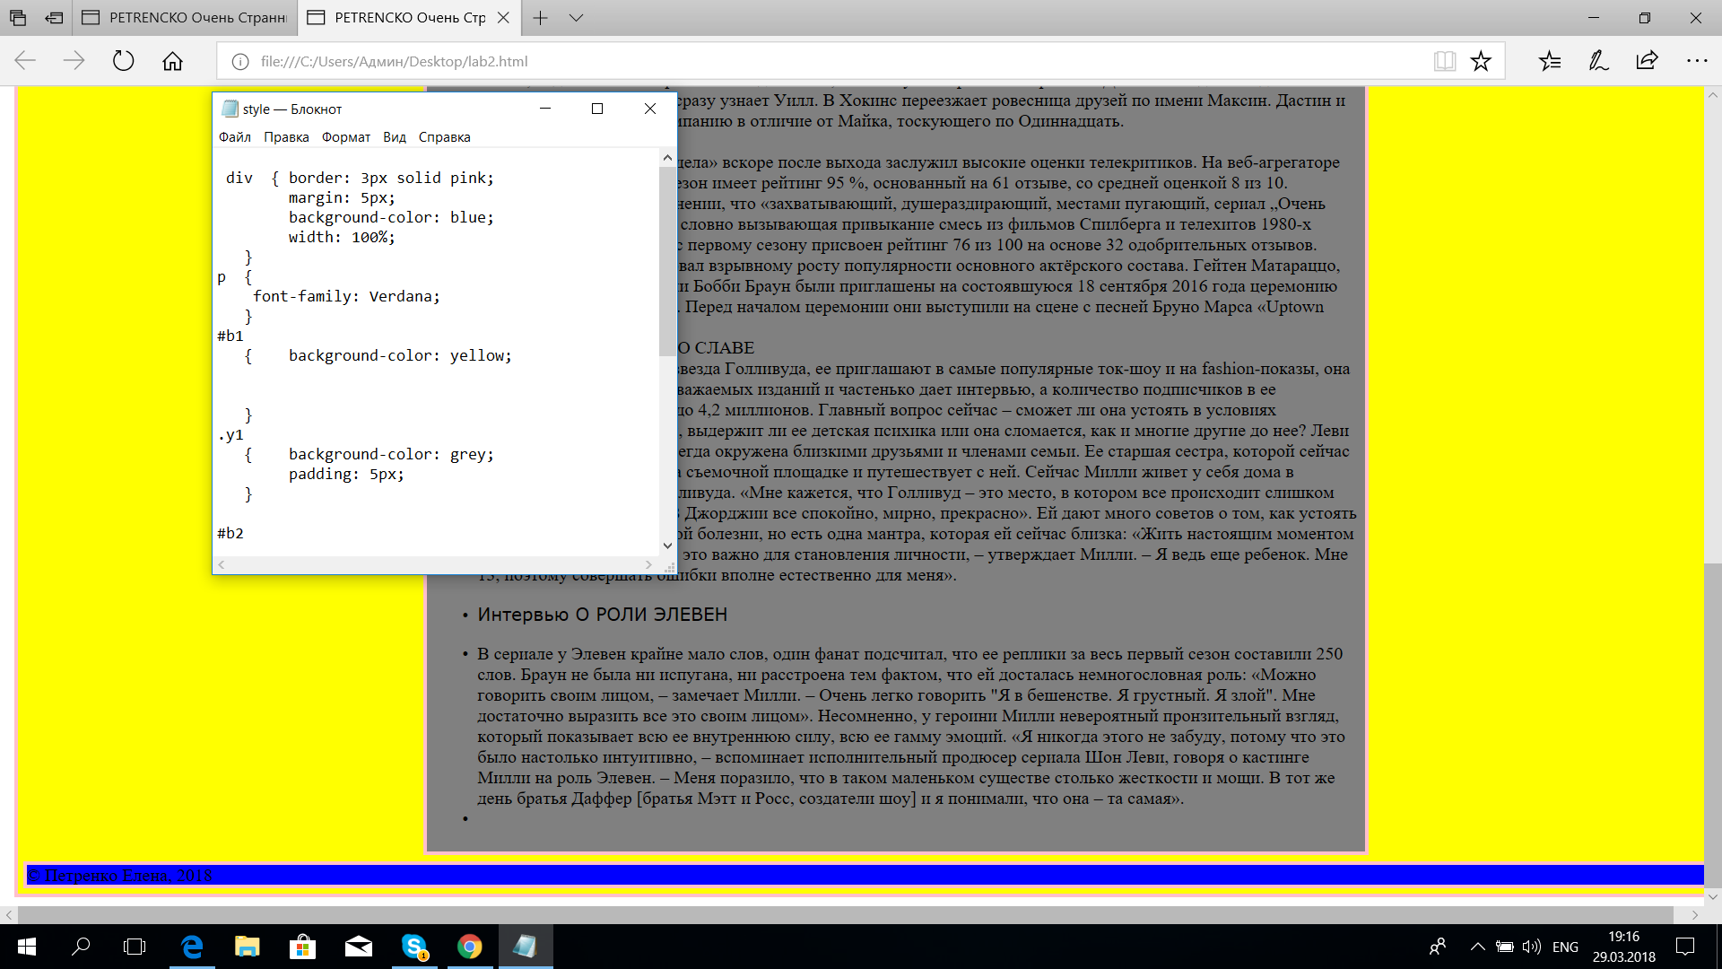

2.2 text-decoration: underline;

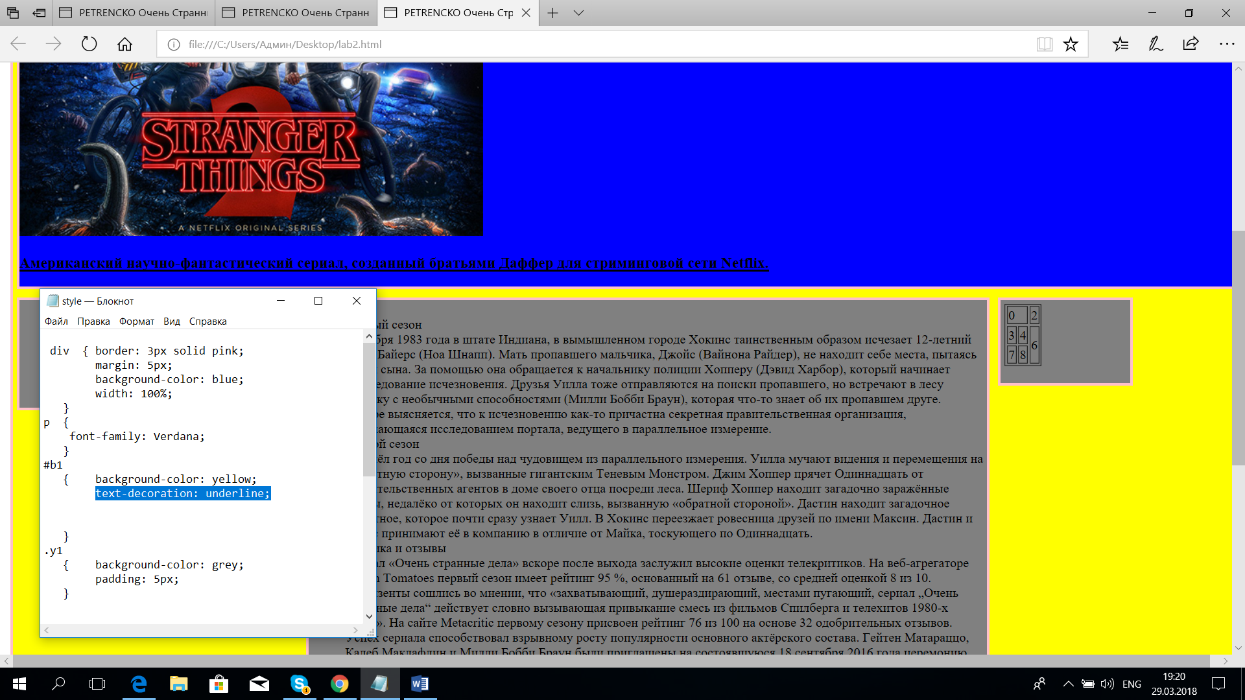

3.1 background-image: url(12.png);

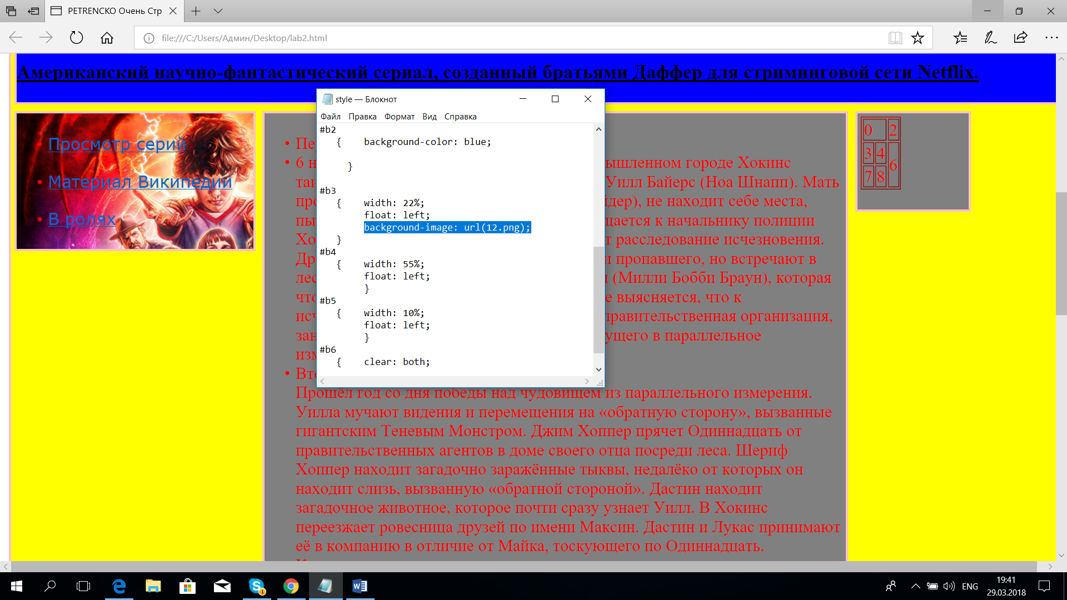

3.2 background-image: url(112.png);

background-repeat: repeat-x

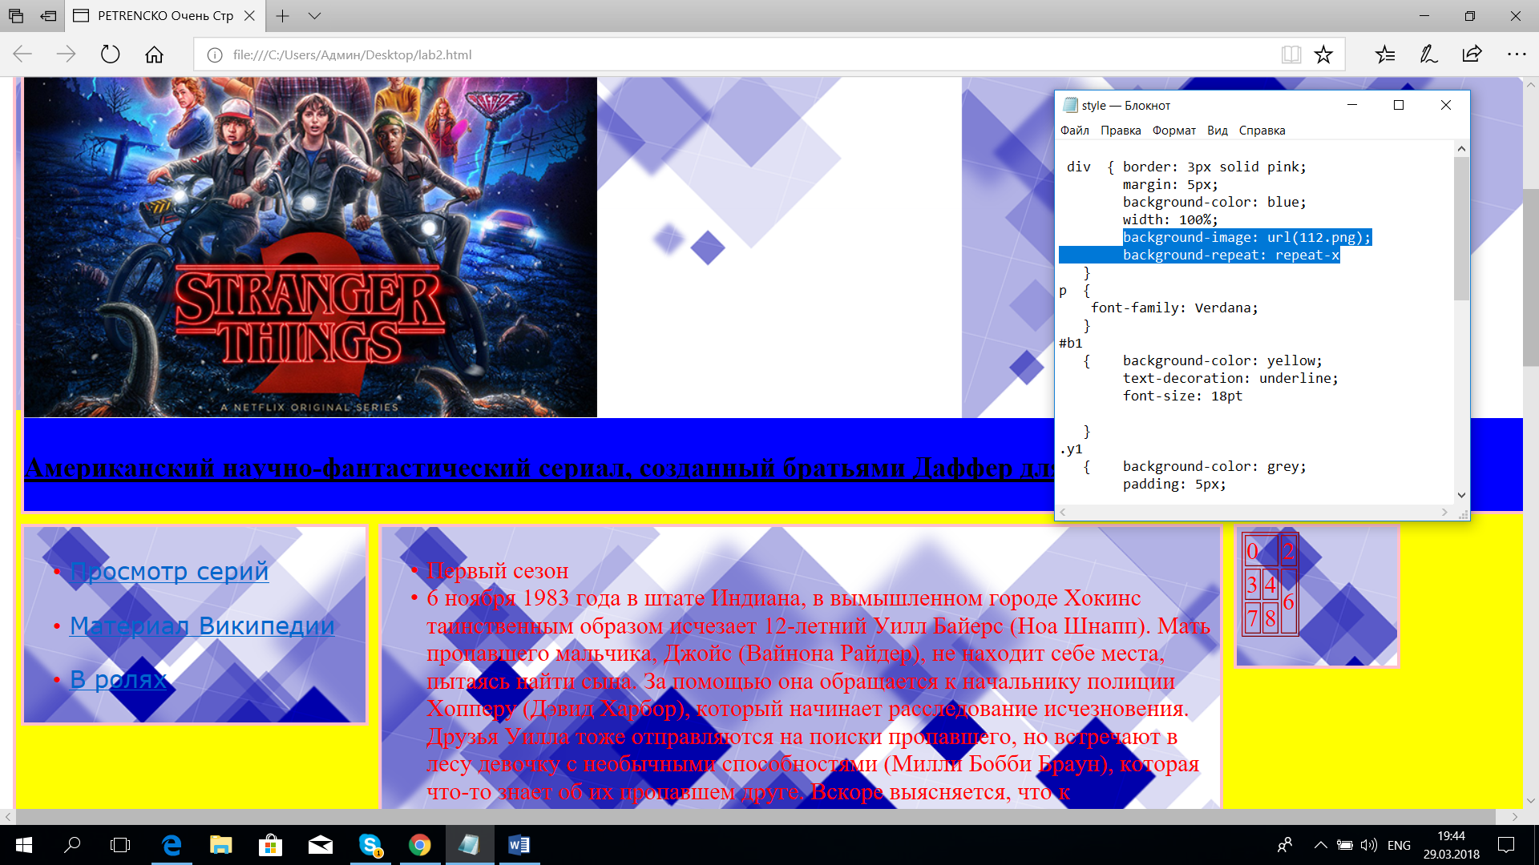

3.3 background-image: url(112.png);

background-repeat: repeat-y

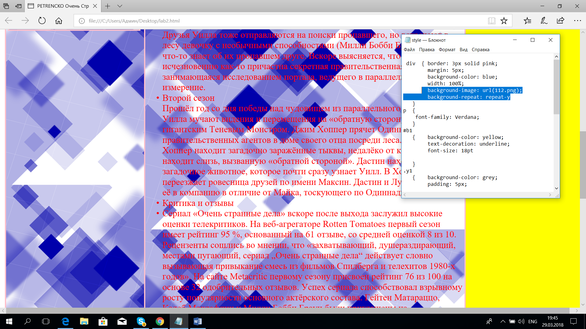

3.4 background-image: url(112.png);

background-position: center 10%;

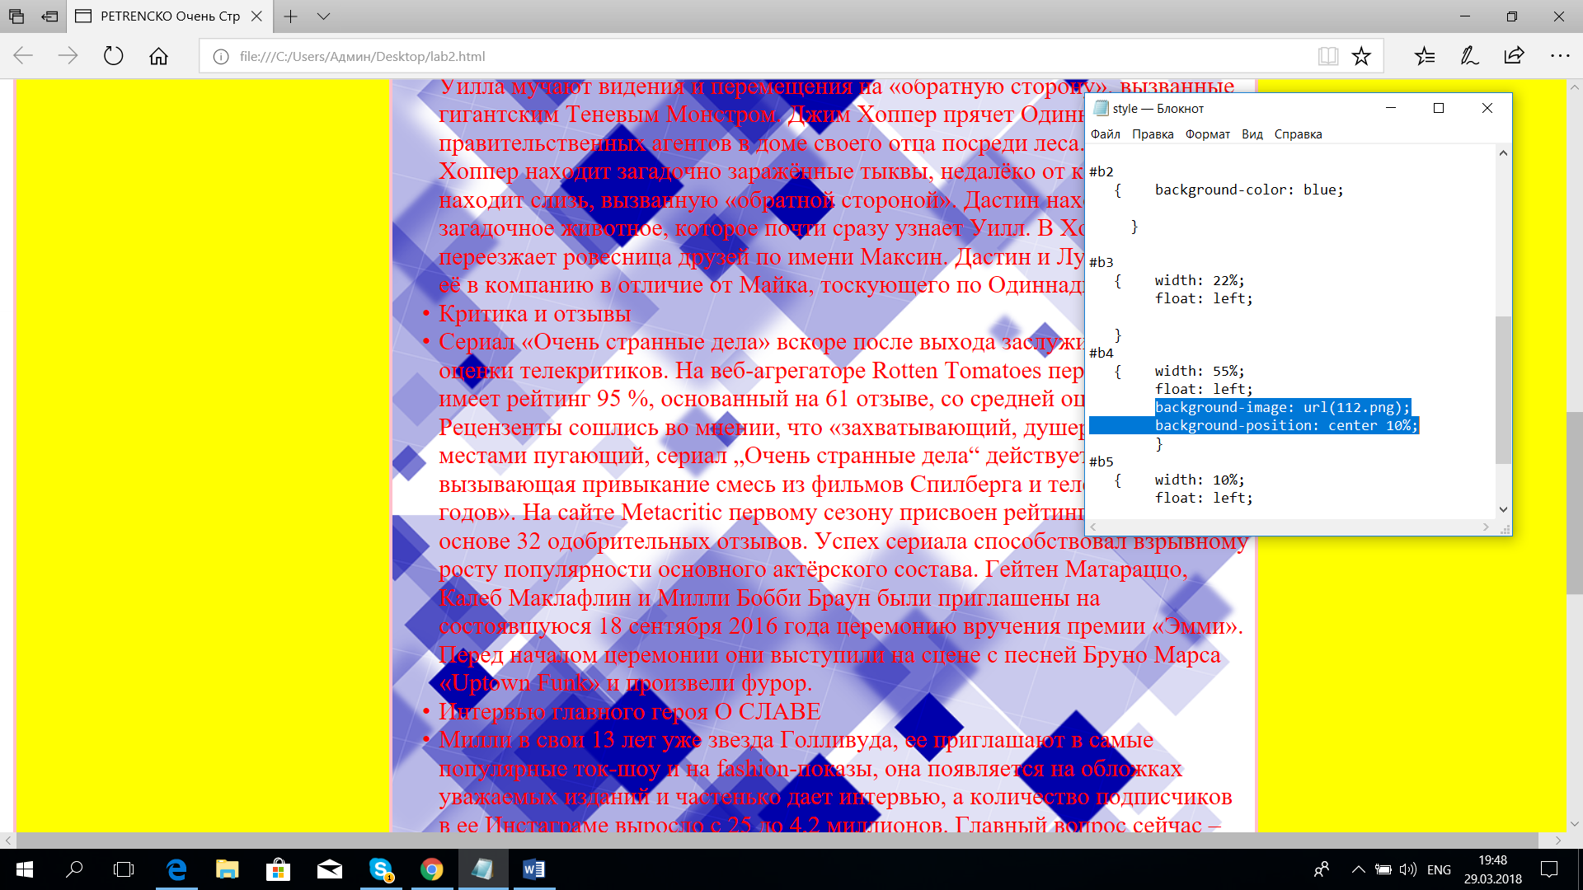

3.5 background-image: url(112.png);

background-repeat: no-repeat;

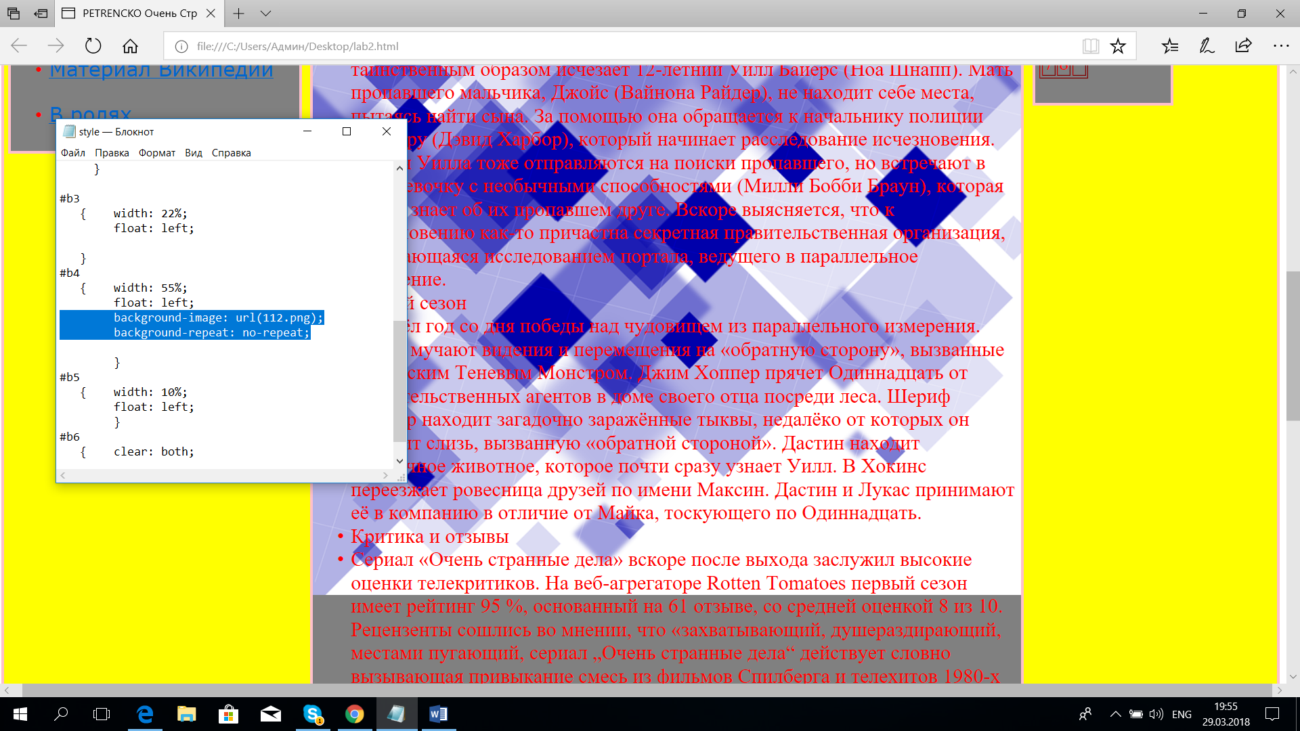

3.6 background-image: url(112.png);

background-repeat: no-repeat;

background-position: bottom;

